**myWatchlist – User guide**

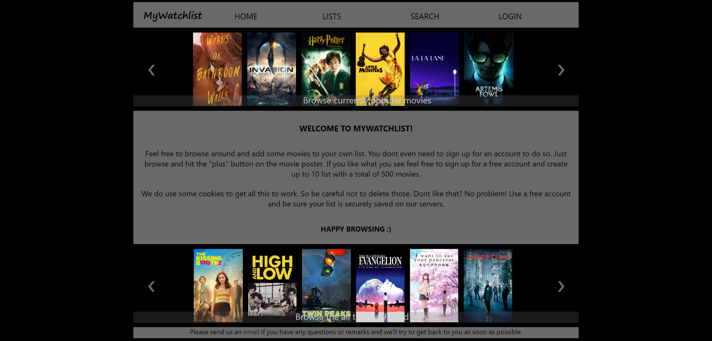

**Version 1.1 / 2020**

## Contents

1. Introduction 3

2. Basic features 4

2.1 Home page features 4

2.1 Searching and adding movies to a list 5

2.2 Viewing and deleting movies in a list 6

2.3 Movie page features 7

2.4 Selecting the current list 8

3. Account management 10

3.1 Creating a new account 10

3.2 Signing out and account deletion 12

4. Administrative functions 13

4.1 Accessing the Admin page 13

4.2 Admin page features 13

4.3 Creating a new Admin account 14

5. System operations 15

5.1 Application first run 15

5.2 Application system account 15

5.3 Precautions to Admin’s 16

# Introduction

The application “myWatchlist” provides users to create one or more lists of movies the user likes to keep track of. Movies can be added to a list by selecting the “Search” button at the top of every page within the application. Additionally the application provides the user with recommendations based on either popularity, all-time best rated movies, or similarity throughout different sections of the application.

A user account is not required to use the application although usage will be restricted. Without creating a user account the user is limited to using a single list and the user’s data is stored within cookies. This gives new users the ability to quickly review the application before signing up.

When a user creates an account the default list (stored as a cookie) can be imported to their account where it will be stored in the database.

To limit the load on the database users that are not signed in or choose to use the application without creating an account will not be able to make use of the applications database.

# 2. Basic features

# 2.1 Home page features



Under the navigation bar this page displays a slideshow of movies based on current popularity. The slideshow banner can be navigated by using the arrows on either side and a when the end of a list is reached the user will be notified by a popup message at the bottom of the screen.

At the bottom of the page a similar slideshow is displayed. This slideshow contains all-time best rated movies.

Both slideshows contain 20 movies and are updated with new content (if available) every 60 minutes.

The middle section of the page holds a welcoming text to the user and this section can also be used to communicate any changes or updates otherwise.

At the bottom of the page is a small text and a link which will open the users default email program which can be used to contact de organization.

# 2.1 Searching and adding movies to a list

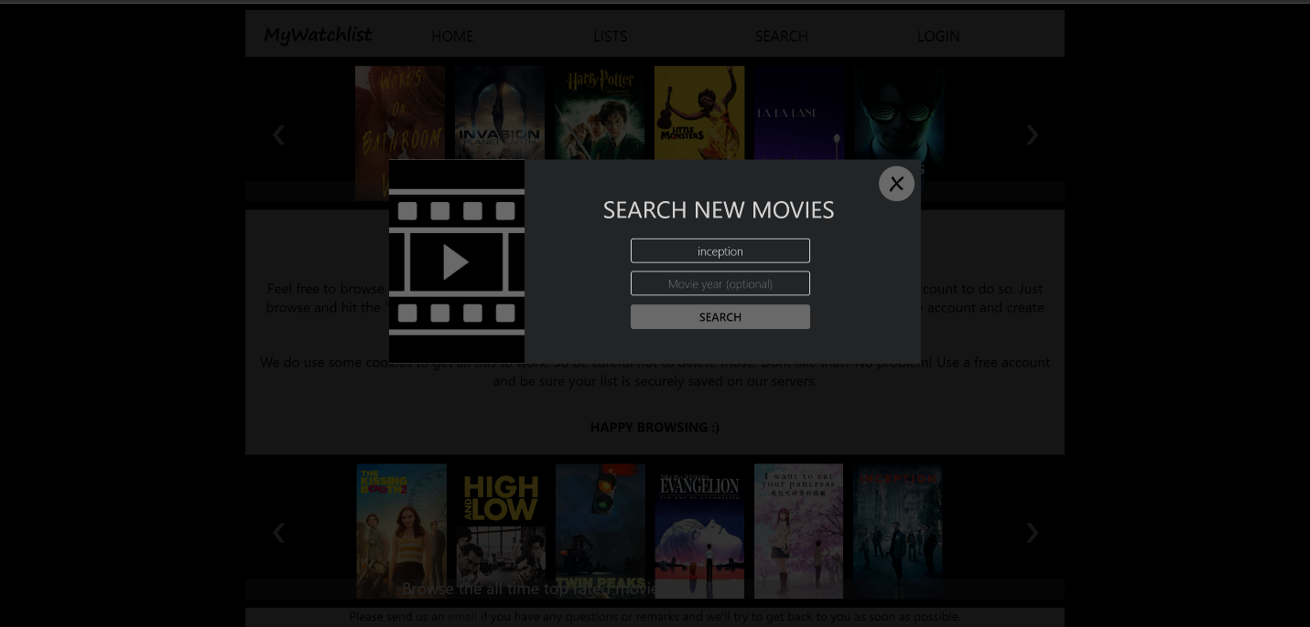

A search for a movie can be performed by selecting the “Search” button at the top of every page within the application. This will open a popup which allows the user to specify a title and optionally a year with which the search will be performed. Click “ Search” to perform a search. If the minimum requirements are not met (title) the user will be notified by a popup message at bottom of the screen.

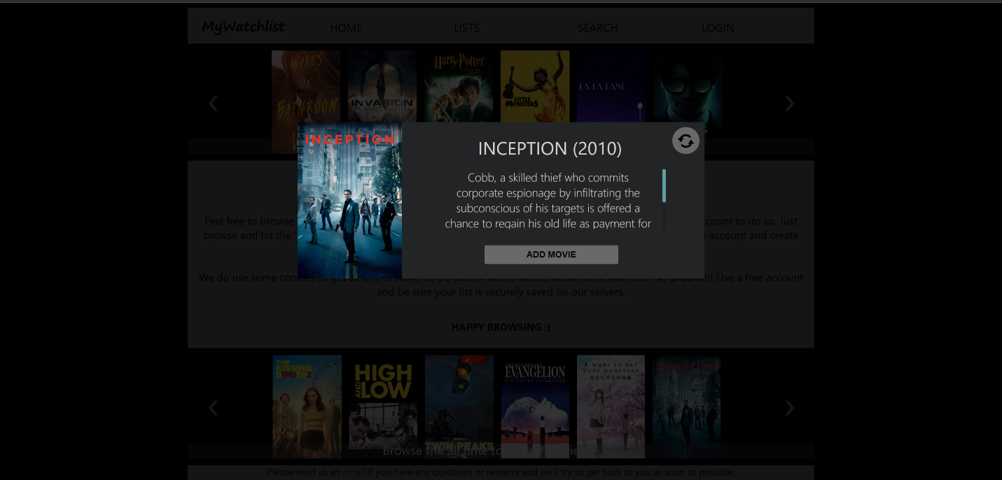

The application will provide the user with the first match resulting from the performed search. The user can either add the displayed movie to their currently selected list (more details on selecting lists in paragraph 2.4) by pressing the “Add movie” button or return to the previous screen by selecting the “refresh” icon in the upper right corner.

When either a movie is added or the refresh button is selected the user is returned to the previous screen which now also includes the option to view the next result matching the search parameters. The user can cycle through all search results by going back and forth between screens as described by clicking on the “next result” button.

# 2.2 Viewing and deleting movies in a list

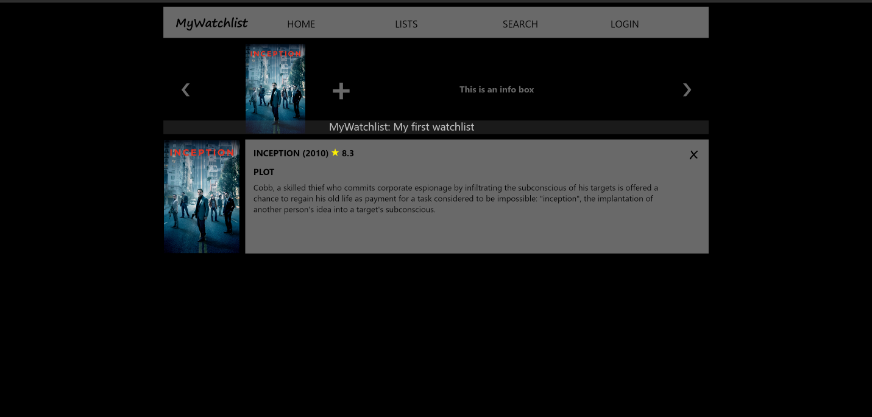

By selecting the “MyWatchlist” logo at the top left of every of every page within the application the user is directed to the “List page” which displays the currently selected list.

Under the navigation bar this page displays a slideshow of movies contained in the current list. The slideshow banner can be navigated by using the arrows on either side and a when the end of a list is reached the user will be notified by a popup message at the bottom of the screen.

The “Plus” icon opens the previously described “ Search” function and works as described in the previous sub-paragraph. The slideshow banner also contains space where tips can be displayed at the end of the slideshow. Clicking on any movie thumb within the slideshow banner will move the relevant “movie slide”, as displayed below the slideshow banner, to the top of the list of “movie slides”. This feature reduces the required amount of scrolling when lists become longer.

When either clicking on the movie poster depicted on the left of the movie slide or clicking on the movie title, the user will be directed to the “Movie page” which displays detailed information of the movie. On the top right of the movie slide a cross is depicted which will delete the movie from the currently selected list.

# 2.3 Movie page features

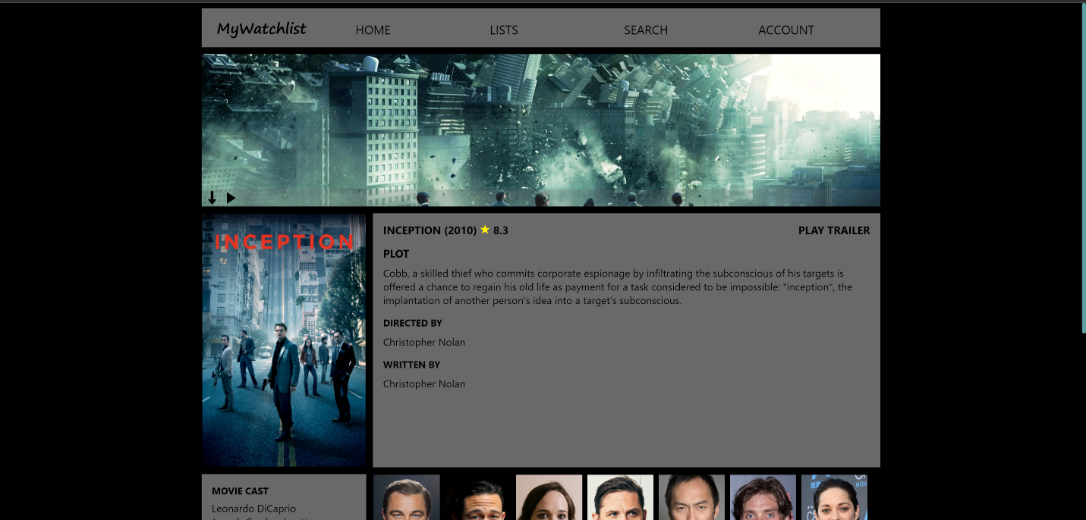

The movie page features a banner below the navigation bar depicting the movie “backdrop art”. The bottom left corner of the banner contains a contextual menu. Clicking on the arrow will unfold the banner so the “backdrop art” can be displayed in full. The “Play” icon also unfolds the banner but when doing so the “backdrop art” is faded out, the movie trailer is revealed and playback is started. The “Play trailer” button depicted to the right of the movie title has the same functionality.

Once playback has started de “Play” icon will toggle to a “Pause” button and vice versa depending on the playback state of the trailer. Additionally, once playback has started, a “Refresh” icon will be displayed enabling the user to restart playback of the trailer from the beginning.

When hovering over the movie poster a “Plus” icon will appear over the movie poster which will add the movie to the currently selected list once clicked. *If the movie in question is already added to the current list a “Minus” icon will appear which will remove the movie from the currently selected list once clicked*.*

*Feature is not yet developed but is added to the backlog.

Below the movie poster and the information pane cast information is displayed. On the left side of this section the cast names are depicted and to the right side the cast pictures are depicted. Each cast picture holds an overlay containing the name of the actor and the role played in the relevant movie. The text in this overlay will scroll back and forth when hover over.

Below the cast information section a slideshow is shown (similar to the slideshows on the home page) which features movies that are similar to the currently displayed movie on the movie page. Clicking on any of these movie thumbs will direct the user to the movie page of that particular movie.

# 2.4 Selecting the current list

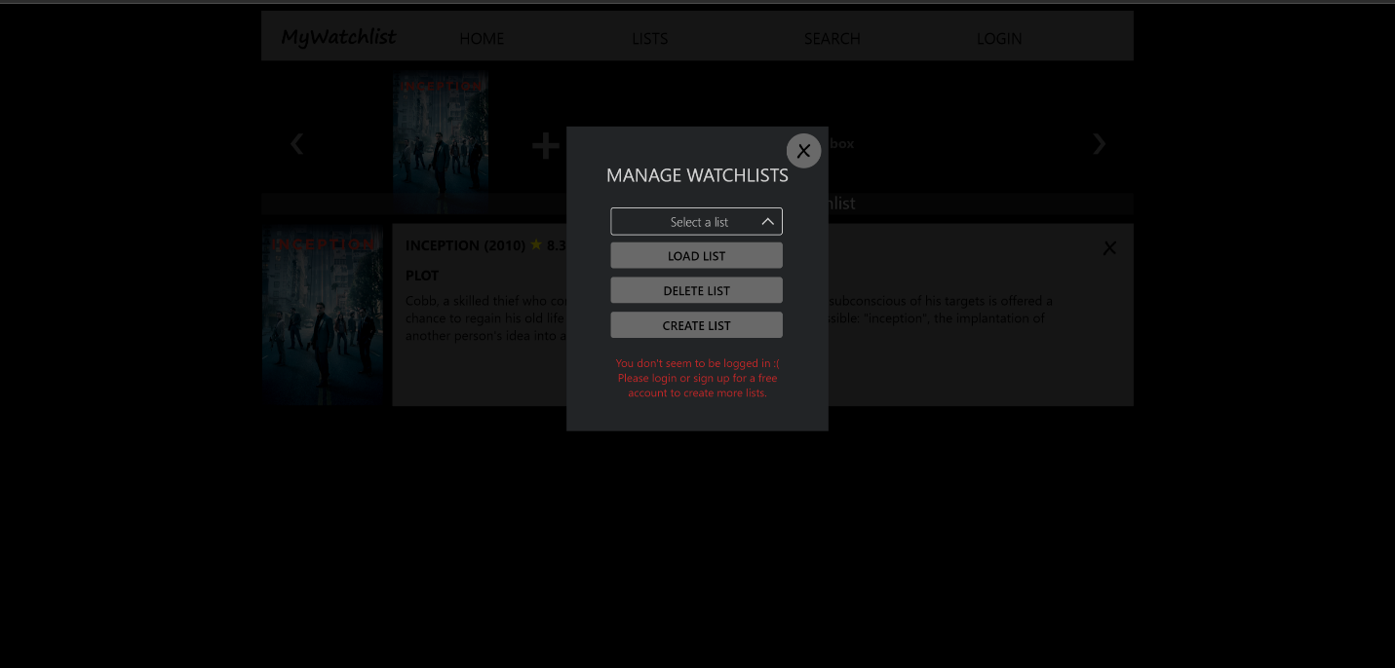

A popup window revealing options to manage the user’s lists can be opened by selecting the “List” button at the top of every page within the application. If a user is not logged in these functions will be disabled and a message will be displayed to the user stating they are logged out.

If a user is logged in the dropdown list can be used to select an existing list. By default every user has a list called “MyWatchlist”. Once a list is selected the user can load this list by clicking the “Load list” button. The list will be retrieved from the database and the user will be directed to the list page which will now display the contents of the selected list. In this way the “currently selected list”, as referred to in previous paragraphs, can be selected. Adding movies to a list, as described in the previous paragraphs, will only effect the last list loaded. When a user signs into their account the first list saved to their account will be set as the “current list”. This would usually be the default list unless the default list has been deleted.

A list can be deleted by selecting it from the dropdown menu and pressing the “Delete list” button. A new list can be created by pressing the “Create list” button.

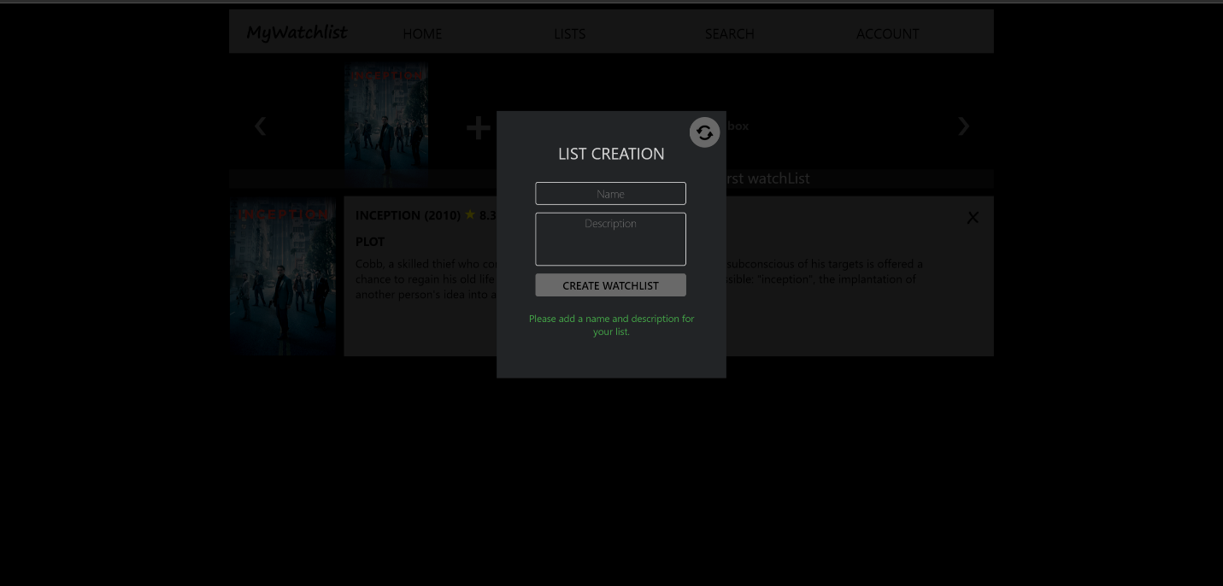

Once the “Create list” button has been pressed the “List creation” menu is displayed. Here the user can enter a name and description for the new list (both fields are mandatory). Once all fields have been filled out the user can create their new list by pressing the “Create watchlist” button and the user will be directed to the list page which will now display the new empty list. The new list will be set as the “currently selected list”.

# 3. Account management

# 3.1 Creating a new account

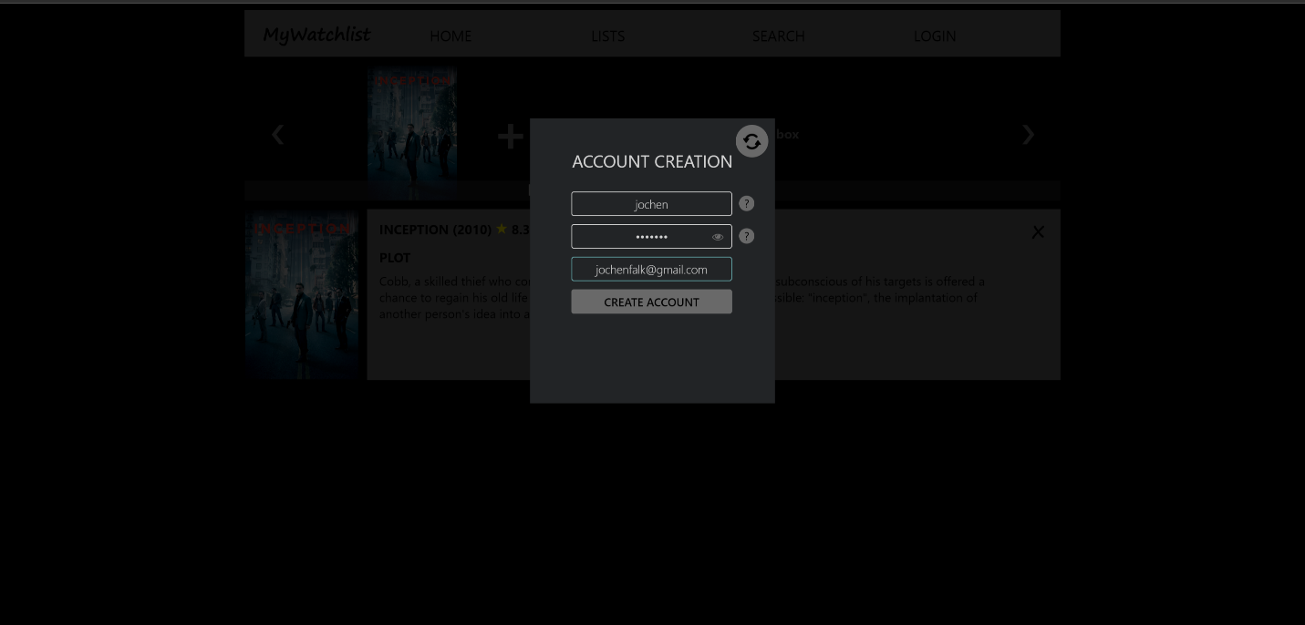

A popup window revealing a login menu can be opened by selecting the “Login” button at the top of every page within the application (under the condition the user is logged out). This menu allows the user to login to their exiting account by filling out both fields and pressing the “Login button”. A new account can be created by pressing the “Create account” button. Doing so reveals the “Account creation” menu.

Within this menu the user must specify a username, a password and a valid email address. Requirements for the username and password fields are shown when hovering over the adjacent “?” icons. Once all fields have been filled out the user can create their new account by pressing the “Create account” button. Before starting the account creation process all fields will be validated and the user will be notified by a persistent message displayed within the menu if one or more fields do not match the requirements. Otherwise the account creation process is started and a loading animation is displayed.

When all fields have successfully been submitted a message will be displayed informing the user an email was sent to their email account with a verification link. After a small delay the menu is automatically closed.

The verification link contains a user specific token and will open a separate browser tab which will continue the registration process.

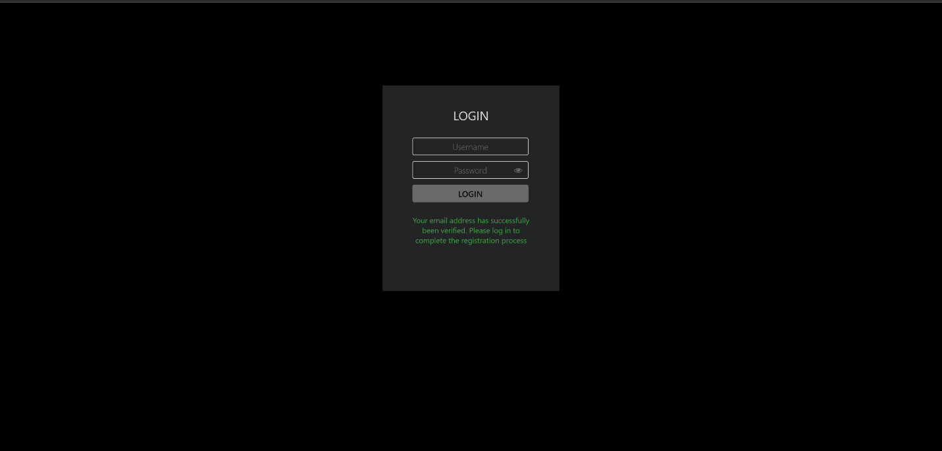

On loading of the new browser tab the user token will be matched to any existing user token contained in any user account within the database. Once a match has been obtained the user is greeted with the login menu. A persistent message is displayed within the menu informing the user of a successful registration of their email. The purpose of this step is to determine that the email account used in the previous step is a real email address.

The user is now prompted to login using the credentials that where created in the previous step. Once all fields have been filled out the user can login by pressing the “Login” button. During the initial login procedure as described here, the system will match the provided credentials to the user account that was matched to using the user token embedded in the link (no other account will be attempted to match with the provided credentials). The purpose of this step is to verify that the user which initiated the account creation process is the same user that has access to the email address used.

If the wrong credentials have been submitted a persistent message is displayed within the menu informing the user to verify their credentials. A new attempt can be made.

After a 24 hour period the embedded token will expire and the page will instead display a persistent message informing the user that the email verification process failed.

At this point the user can request a new email including a new link with a new embedded token via by entering their email address and pressing the “Request link” button. On submission the email address will be matched against any email address found in any user account within the database and if found a new email is sent informing the user that a new verification link was requested for their account. Using the link within this email will restart the verification process as described above. The amount of times a request is made is stored in the user account.

When the user successfully logs in and completes the registration process the account will be activated and the user will be directed to the applications home page.

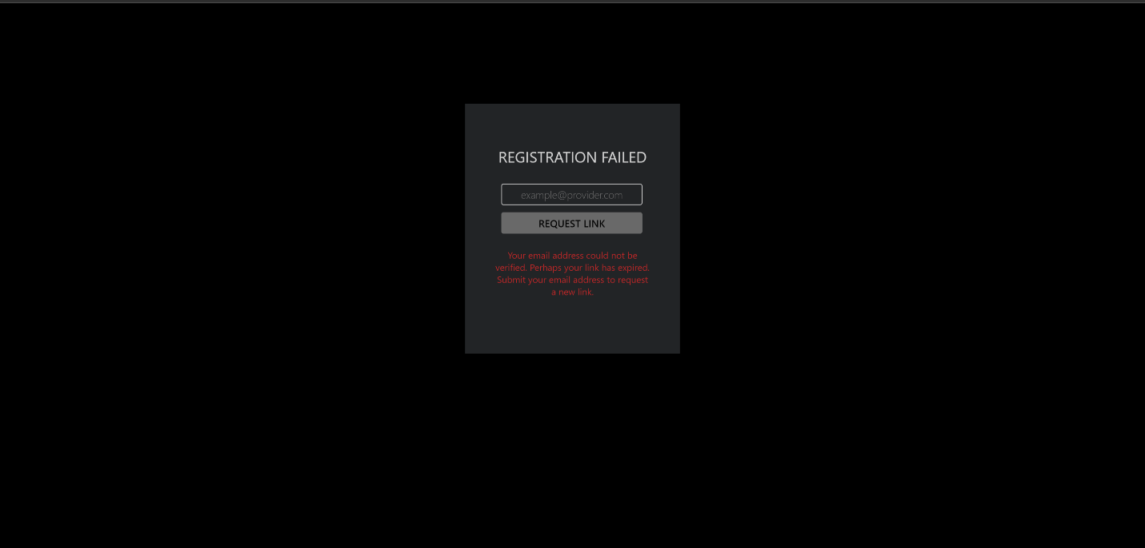

# 3.2 Signing out and account deletion

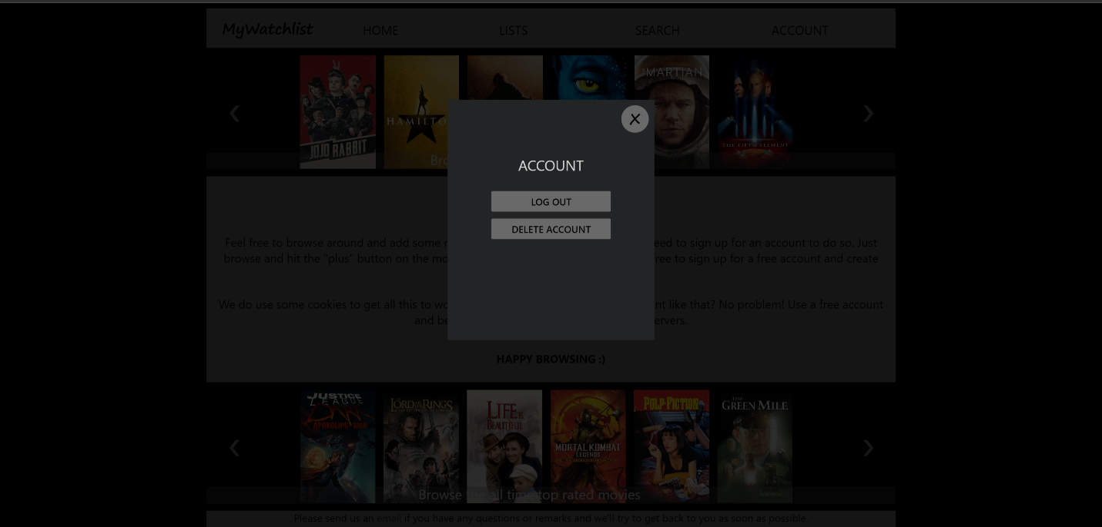

A popup window revealing a account menu can be opened by selecting the “Account” button at the top of every page within the application (under the condition the user is logged in). This menu allows the user to either logout or delete their account by respectively pressing the “Logout” or the “Delete account” button. A user is automatically logged out after 15 minutes of inactivity or when the browser window is closed.

# 4. Administrative functions

# 4.1 Accessing the Admin page

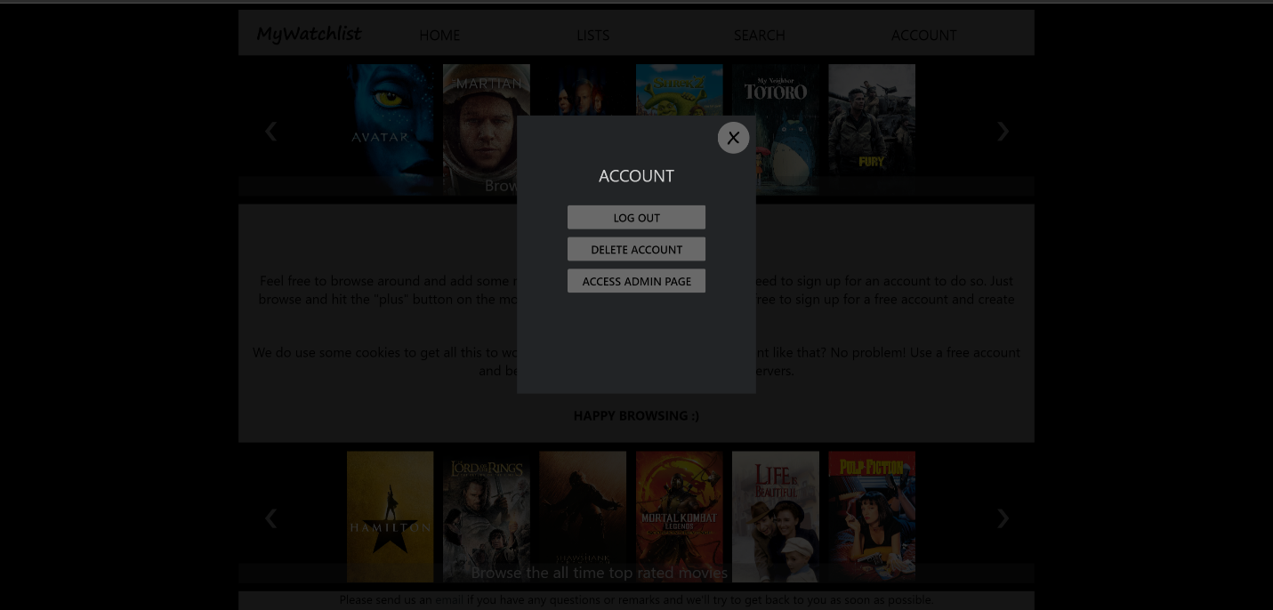

Every time the “Account” menu is opened the “role” of the user is verified. And if a user is verified as an “Admin” an additional menu item will we displayed. Pressing the “Access admin page” button will direct the user to the Admin page. The same verification is done when a user manually enters the URL of the Admin page and in case the user does not have the “Admin” role the user is directed back to the Home page.

# 4.2 Admin page features

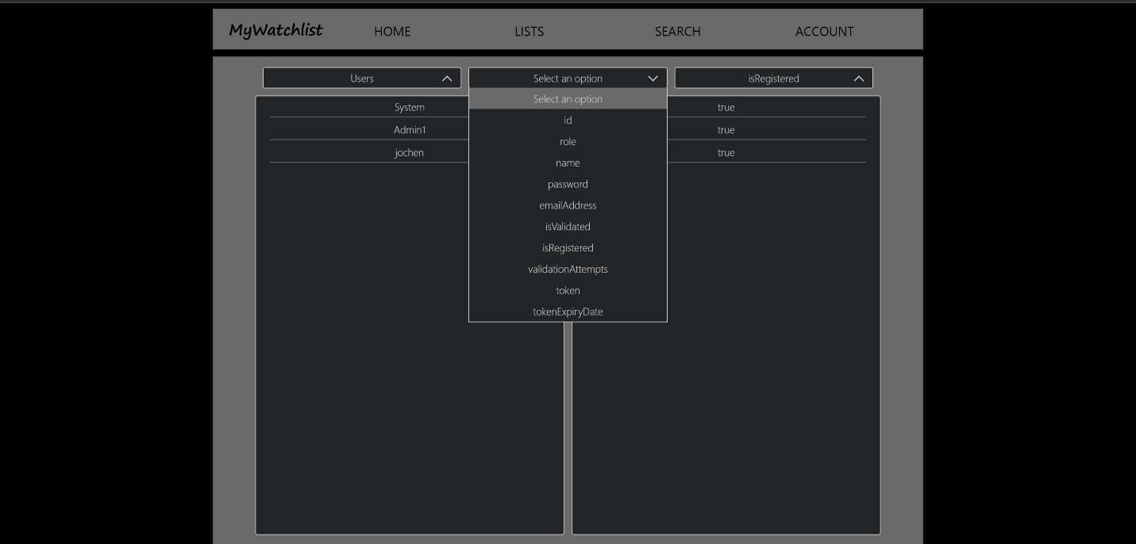

When the Admin page is accessed the Admin is presented with 3 dropdown lists of which only the 1st is accessible. Here the Admin can make a selection between Users, Lists, Search results and Messages (emails). Once a selection is made the other dropdown lists become accessible and from these dropdowns sub categories can be selected. Subcategories can include the ID’s, usernames, list names, email types, etc. The width of the columns is automatically adjusted depending on how many selections have been made to accommodate for clarity.

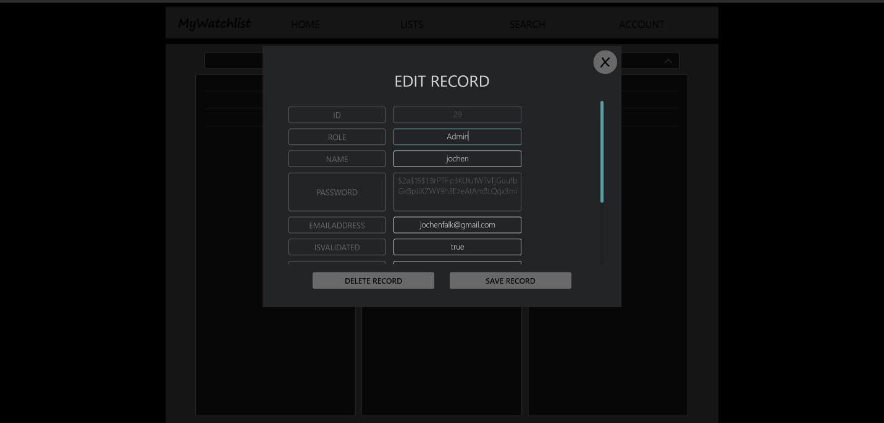

When the Admin clicks on any row, regardless of the column, the associated record is opened in a popup menu. From this menu all sub categories of the specified record can be viewed by scrolling down the menu. Any field that is not grayed out can be directly modified. The record can then be saved by pressing the “Save record” button. Any changes made before saving the record are cancelled when the menu is closed by pressing the “X” icon in the top right corner. The record can be deleted in full by pressing the “Delete record” button.

*Note: Some items are greyed out and cannot be changed by the Admin. This is a needed precaution to ensure the consistency of the database.*

In a future update additional features will be added to this menu allowing the Admin to combine associated records (such as the lists belonging to a specific user) in a single view.

# 4.3 Creating a new Admin account

A new admin account can only be created by changing the role of an existing account. The account creation procedure is there for the same as previously described. Once the account is created another Admin can change the role from “User” to “Admin” thereby giving that user Admin privileges.

# 5. System operations

For detailed information on installing the application please refer to the “Installation guide”.

This section explains what the application will do at first run, when restarted and how certain system operation work. Admin’s should be aware of these on goings and should take special note of the precautions mentioned in paragraph 5.3.

# 5.1 Application first run

When the application is run for the first time no accounts will be stored in the database. In order to facilitate certain system operations and give initial access to the Admin the necessary accounts will be created.

The system will create the default admin account. Credentials for this account are provided in the confidential system configuration. Please refer to your system manager if required. Due to the nature of a default Admin account it is of the upmost importance that a new Admin account is created as soon as possible and the default Admin account is deleted.

Additionally the system will create a default system account which can be used by the application developers / helpdesk whenever the application has encountered a fatal problem. The credentials to this account are not specified in the confidential system configuration.

# 5.2 Application system account

As mentioned in the previous paragraph a system account is created on application first run. Besides allowing outside access to the application in case of a fatal problem the system requires this account to perform certain system operations like creating system lists used on the Home page.

It is therefore of the highest priority that this account is not deleted or renamed as it will result in the inability of the system to work.

Every time the system is restarted the existence of this account is verified and in case it cannot be found it will be recreated. As an additional precaution also the default Admin account will be recreated. Therefore, in the misfortunate case that this has happened by accident the system should be restarted as soon as possible. Contact your system manager in the event this has occurred in order to have the integrity of the database checked as certain write functions may have been partially completed. And delete the recreated default admin account.

# 5.3 Precautions to Admin’s

* The default Admin account should be deleted as soon as possible but not before creating a new Admin account.
* The default system account should never be deleted or renamed.
* If the default system account cannot be found at system restart it will be recreated.
* If the default system account cannot be found at system restart the default Admin account will be recreated.
* Via the Admin page it can be observed that the system account has performed certain activities like creating certain movie lists.
* It is possible to delete the account currently used by the Admin.